**Section 11 done: 33/33 Multi-Page-Feeling in a Single-Page-App: Routing**  
**Introduction**  
* React in its core is just a Component Creation Library, now we’re turning it into much more like a Framework by adding a major feature - Routing.  
**Routing and SPAs**  
* Routing is about being able to show different pages to the user.  
* In SPA we don’t actually have multiple HTML files, we instead use JavaScript to render different pages for different paths.  
* This is what Routing is about - parsing this path - so the part after our domain and showing the appropriate JSX or component code in our app.  
=> We’re using a package to parse the path, also so that we don’t have to figure which path the user is on on our own.  
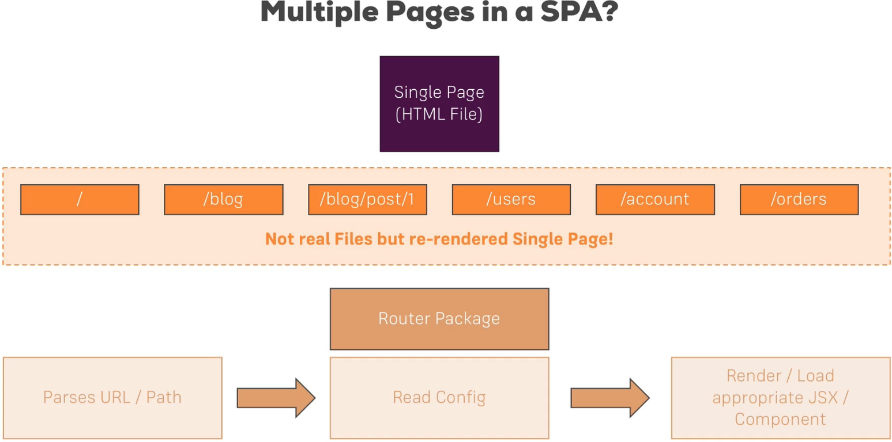  
**Setting Up Links**  
* We’ll use our blog app for learning.  
* Now the links can simply be added to our Blog.js container, and you could of course outsource them into their own component but I wanna keep this lean so that I can focus on that Routing functionality.   
* We will then see a real-world setup in our course project.  
* In Blog.js after render() inside return():  
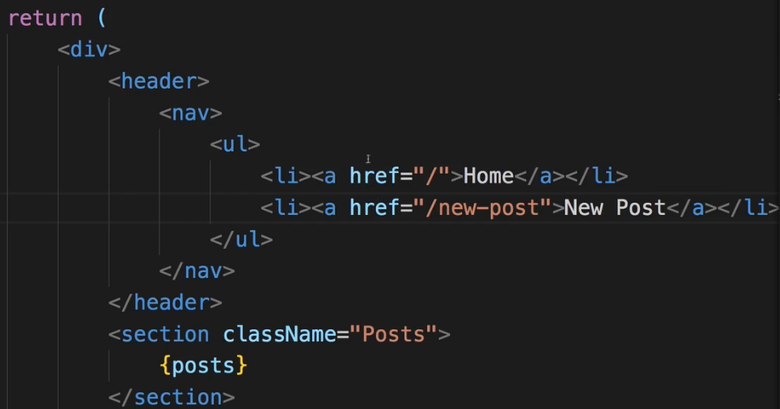 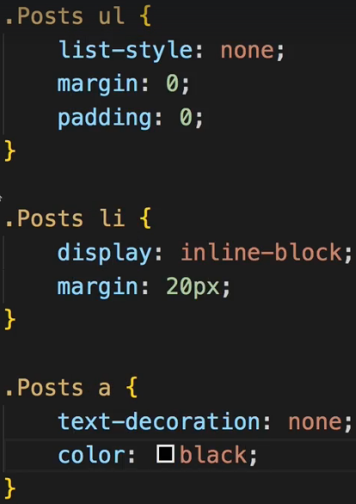 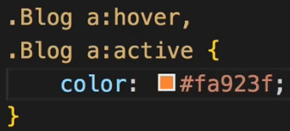  
* We would add the .Posts to the DIV, we actually already have .Posts so we rename it to .Blog. And we add text-align: center.  
* Right now the links actually always return the same page, this is related to the way our development Server is set up and the production Server should also be set up - it always returns the index.html file for every route because for the Server there are no different routes, there is only 1 single file it has to return all the time.  
=> It’s now about parsing that URL in the Client.   
**Setting Up the Router Package**  
**npm install --save react-router react-router-dom**  
* react-router contains the logic but to be able to render something to the DOM so to tell React to render something, we need react-router-dom.  
=> **We enable routing in App.js or index.js file**.  
=> **Wrap the part of your app which should be able to render routes and to read routes with a component you import from the react-router-dom package**.  
=> **BrowserRouter**.  
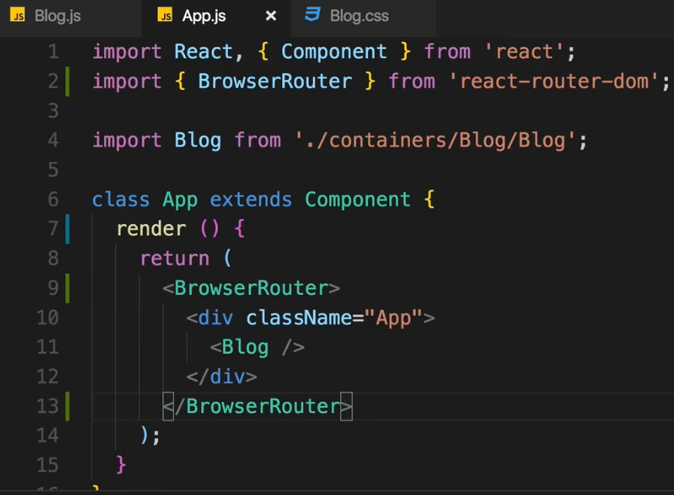  
=> **This is now the router of this application and now we can use routing features from that routing package anywhere inside this wrapping component**.  
* In Blog.js:  
* I’ll create a new component for the posts section.  
=> Actually you could turn all these components  
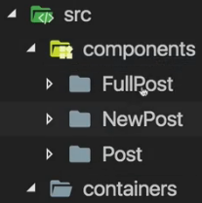  
into containers now because they will be distinct pages which typically have sub-components, distributing their state to them.  
* Creating a new folder: `posts`.  
* Now this `Post` folder I leave in `components` because it’s really just presentational.  
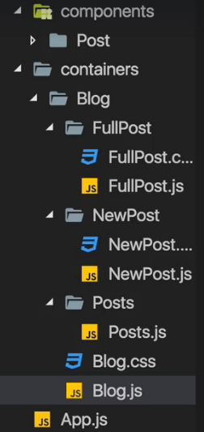  
**react-router vs react-router-dom**  
We installed both react-router  and react-router-dom . **Technically, only react-router-dom  is required for web development**. It wraps react-router  and therefore uses it as a dependency.

We **don't need to install**react-router  on our own for it to work. You can omit this installation step, I left it in there for historic reasons and because I like to emphasize that the main package is named react-router. If you ever search for assistance, you probably want to search for "react router" - that's the name of the package.  
**Preparaing the Project For Routing**  
* We moved most of the components to the `containers` folder because now we’re going to load them as pages through routing and that really turns them into containers because they’re no longer included by some other component - yes, kind of, through routing - but they really are now on the root level, being exchanged for previously root level components.  
* Moving the posts variable and state from Blog.js to Posts.js and also the postSelectedHandler and the componentDidMount() so I only have the render() in Blog.js.  
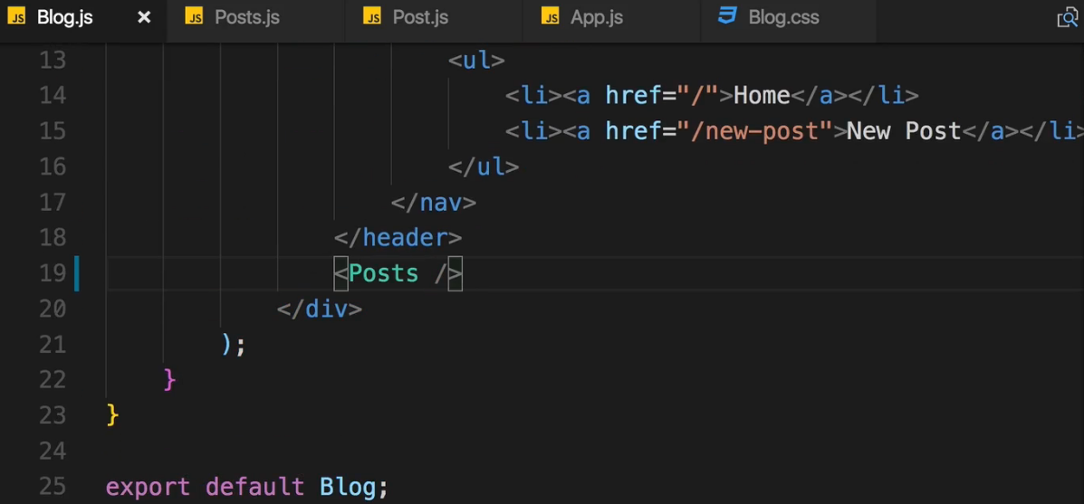 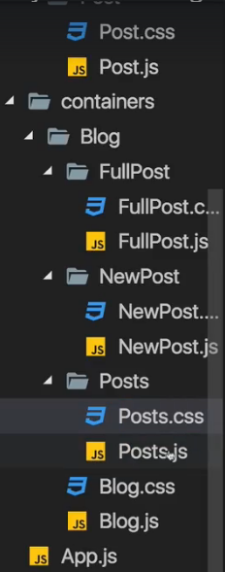  
* Now we got different containers which we can use as pages in our app because we want to load either all posts or a single post or the new post page.  
**Setting Up and Rendering Routes**  
* In Blog.js:  
  
=> **Route**. The Route component. We use it like any other component in our JSX code and it’s a self-closing component.  
=> Route needs some configuration though.  
  
=> It needs a `**path**` property and it is of course a reserved word, it’s expected to be named like this by this component so you can’t change the name.  
=> Now in its simplest form you can now add `**render**` prop which actually holds a reference to a function and you can pass an anonymous function - an arrow function. This function should return JSX which should be rendered. And of course you can also render structured JSX here by wrapping it in parenthesis or writing it multi-line, just like you write JSX anywhere else.  
* React Router to determine which path you’re on, sees if your current path starts with this `path`, so if this is a prefix.  
=> You can overwrite the behavior by adding `**exact**` prop. That’s a boolean prop so just writing it like this sets it as true.  
* <Route /> simply replaces itself you could say, with the content you define in `render`.  
* And you can use multiple Route-s even for the same `path`.  
  
=> Now we see both of them displayed, beneath each other.  
* We want to render one of our components.  
**Rendering Components for Routes**  
* This is how to **comment something out in JSX**:  
  
* Now I don’t want to use `render`, I want to use a different property I can pass.  
=> The `**component**` property.  
=> This allows us to pass a component which should be rendered in this Route’s place.  
* Now `component` is not a string.  
* `component` needs to be a reference to the function or class you want to use.  
  
* `render` is mostly important for short info messages, you shouldn’t really render a whole component’s code.  
**Switching Between Pages**  
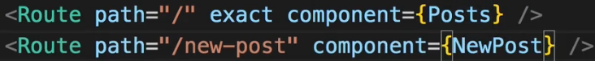  
* Right now our application has an issue though - we can click these links, they are normal anchor tags <a></a> but each time our application actually reloads.  
* Now this isn’t a problem here but theoretically a reloading application means that your JavaScript code is starting anew and therefore all previous application state is lost.  
* As long as the user is navigating around in it, you want to not reload the page, you want to juse re-render the page in the parts where it needs to be re-rendered to look like the new page.  
* So we want to prevent the reloading of the page and let React only re-render part of the DOM that needs to be re-rendered.  
**Using Links to Switch Pages**  
=> **Link**.   
  
* We use this Link instead of the <a></a> anchor tag.  
* Link alone of course doesn’t do much because we need to tell React Router where this Link should lead to.  
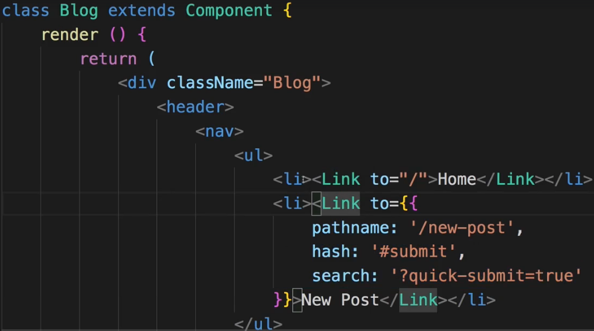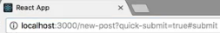  
=> We do this with the `**to**` property. The `to` property in its simplest form is a string. Now this is essentially kind of the same as <a href=””> but React Router will create the anchor tag and then prevent the default which would be to send a new request and instead handle that click on itself.  
=> It can also be a JavaScript object and hence needs to be wrapped in {} to output dynamic content. And there we can now configure where we want to go to.   
=> We can set up a `**pathname:**` which then again is the string that we want to go to.  
=> But we can also now add a potential `**hash:**` tag after that, which we don’t have now but this would allow us to then jump to any ID submit we have in that element so using that feature of appending a fragment after the URL > you can add # in the URL to jump somewhere on the page to some ID.  
=> We can also set up `**search:**` and that allows us to add **query parameters** like this.  
* Now our state in contained, we don’t reload the application.  
**Using Routing-Related Props**  
* Now let’s have a look at the information we actually get in the components we’re loading because React Router gives us some extra information about the loaded route through **props**.   
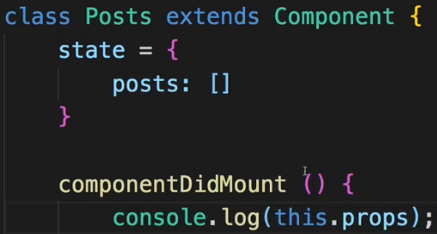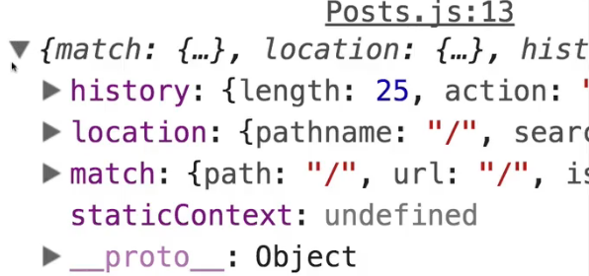  
=> This is not something that we set up, this is passed by React Router.  
=> Now `**match**` gives us some information about the matched route. And potential **params**. We’ll come back to params later.  
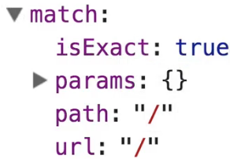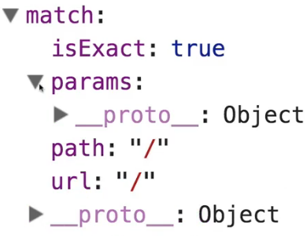 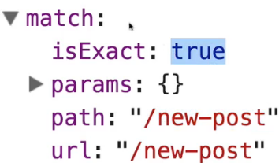  
=> `**location**` and there you see for example the search params we set up and # hash fragment.  
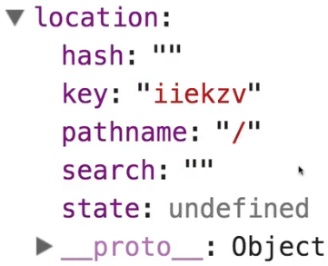 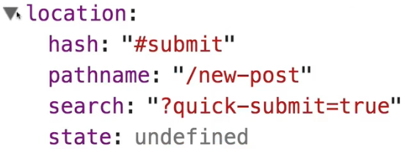  
=> And the `**history**` also has some methods we can use like push - to interact with that and push a new page programmatically without needing a Link component.  
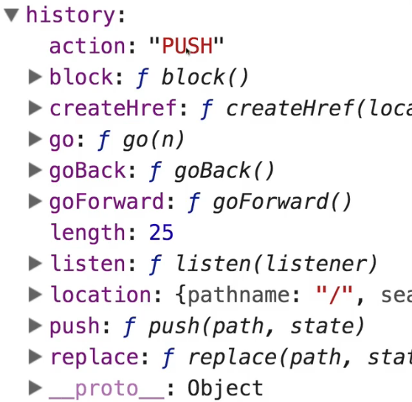  
=> You can use that to for example extract your query params, move to a hash fragment. We will later use this `history` object to use a method it provides us.  
**The ”withRouter” HOC & React Props**  
* Now what if we actually want to get this information not in one of our containers so not in a component which was loaded through a Route as defined in the Blog.js file, but in a component which is rendered as part of such a container. Like the Post.js container.  
=> The Posts container is loaded with the Route, and the Posts container simply renders the Post component.  
* Right now if we console.log() the props in Post.js, there is no information from React Router. So the routing related props are not passed down the component tree. We can’t access them in components which we simply embed as part of the JSX code of a container.  
=> Now if you wanted to use the props there, there are 2 ways to get access.  
=> 1. => We can pass them on with for example the spread operator and this.props.  
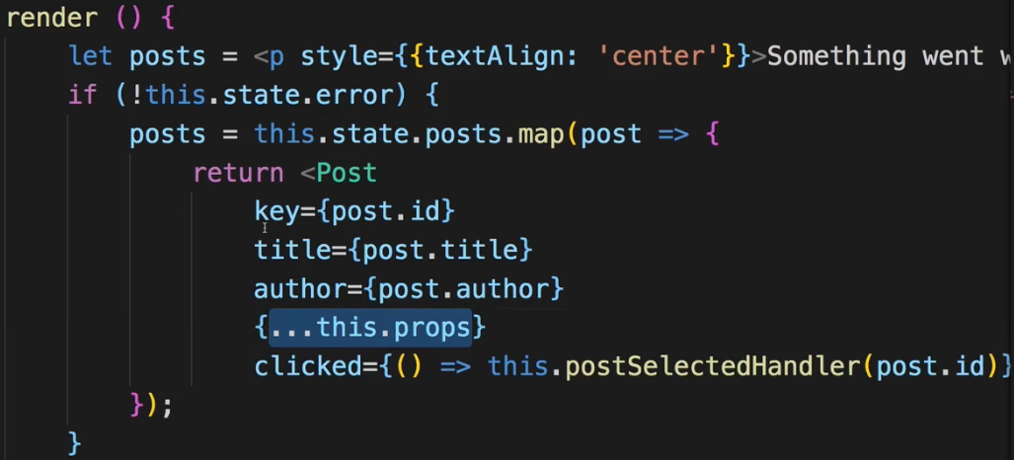  
* You could of course pass just some of them.  
* In Post.js:  
=> 2. => There’s also a HOC - Higher Order Component we can use on the Post.js component.  
=> **withRouter**.  
  
=> **Now `withRouter` is a HOC which we use by wrapping our export with it**.  
  
* Now the props for the individual posts do have the history, location and match properties.  
=> So `withRouter` is a nice way of **making a component route-aware and it will get the props containing the information for the nearest loaded route**, so in this case Posts.js.  
**Absolute vs Relative Paths**  
* One more information about Link-s we set up here.  
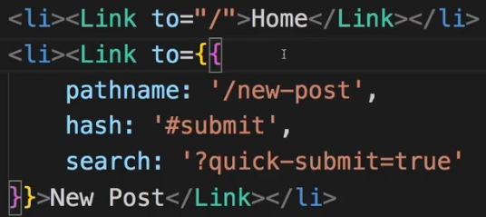  
=> The way you write you links here doesn’t affect whether it’s an absolute or a relative path.  
* **Absolute path** is always appended to your domain. So if you’re serving this from example.com, you’d use example.com/new-posts, even if you previously were at example.com/posts, you wouldn’t add /new-post at the end of that turning it into example.com/posts/next-post - but turning it into example.com/new-post and omitting /post. This is what an absolute path does.  
* Now when setting up “to”, you can’t control whether it’s an absolute or relative path, it’s always treated as an absolute path. So no matter if it’s /new-post or just new-post, it’s an absolute path and will always be appended to your root domain.  
* Now if you wanted to turn it into a relative path - to make sure that if you are on yourdomain/posts, you actually go to yourdomain/posts/new-post, so you append this to the end of the current path, then you actually need to build this path dynamically by taking into advantage that you know which path you’re currently on.  
=> Remember that you have access to `**this.props.match.url**`, which is the currently loaded path in the end. Now you can chain /new-post to this, you can build a dynamic path like this.  
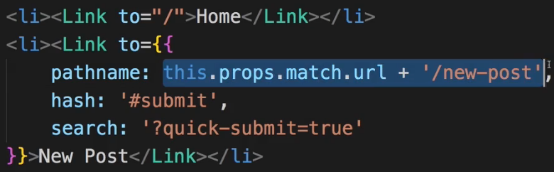  
=> Now it’s a relative one because it takes the page/path we’re currently on and appends this /new-post at the end.  
* So if you even want to build a link which simply appends the path to the end of the current path, use this approach.  
**Absolute vs Relative Paths (Article)**  
You learned about <Link> , you learned about the to  property it uses.  
The path you can use in to can be either **absolute** or **relative**.   
**Absolute Paths**  
By default, if you just enter to="/some-path"  or to="some-path" , that's an **absolute path**.   
**Absolute path** means that it's**always appended right after your domain**. Therefore, both syntaxes (with and without leading slash) lead to example.com/some-path .  
**Relative Paths**  
Sometimes, you might want to create a relative path instead. This is especially useful, if your component is already loaded given a specific path (e.g. posts ) and you then want to append something to that existing path (so that you, for example, get /posts/new ).  
If you're on a component loaded via /posts , to="new"  would lead to example.com/new , **NOT** example.com/posts/new .   
To change this behavior, you have to find out which path you're on and add the new fragment to that  
existing path. You can do that with the url  property of props.match :  
<Link to={props.match.url + '/new'}>  will lead to example.com/posts/new  when placing this link in a component loaded on /posts . If you'd use the same <Link>  in a component loaded via /all-posts , the link would point to /all-posts/new .  
**There's no better or worse way of creating Link paths** - choose the one you need. Sometimes, you want to ensure that you always load the same path, no matter on which path you already are => Use absolute paths in this scenario.  
Use relative paths if you want to navigate relative to your existing path.  
**Styling the Active Route**  
* We’d like to see which route/link is active by styling it appropriatelly.  
* We do this by not using Link but a different type of Link.  
=> **NavLink**.  
  
* It’s pretty similar to Link but it has some extra props which allow us to define some styling for the active link.  
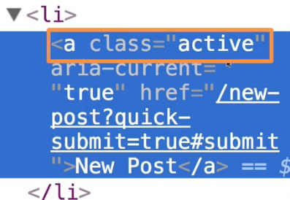 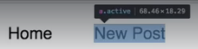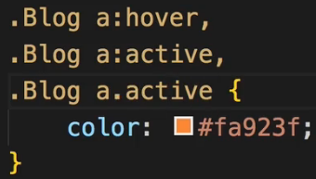  
=> Now when we start, all links have the `active` class, when we click home, it shows correctly. Why is that?  
=> By default it treats all the paths as prefixes. And the same is true for links.  
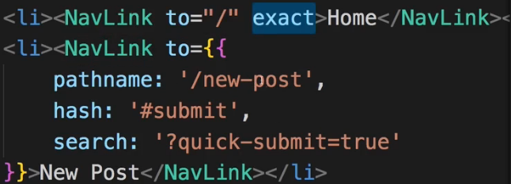  
* Not needed for the second link right now because there we don’t really have any nested links which should not trigger the active class here.  
* Now sometimes you don’t want to use that default of `active`, maybe you want to use a different class name, that’s why you can overwrite the class which should be appended.  
=> The `**activeClassName**` property.  
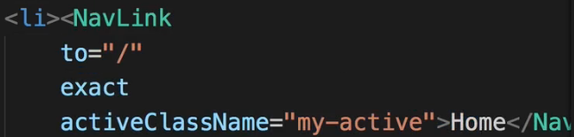  
* You also don’t have to work with CSS classes if you don’t want to, you can also set an active style instead.  
=> The `**activeStyle**` property is a dynamic value, it’s a JavaScript object and it actually works just like inline styling.  
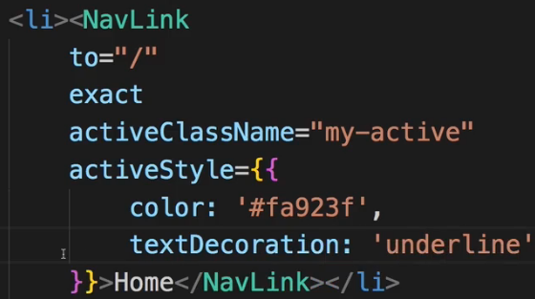  
* We change the `activeClassName` to my-active which doesn’t do anything now, we don’t have it.  
**Passing Route Parameters**  
* Now we need to determine where this FullPost should be shown. We could render it in the Blog.js component, instead of our Posts here. We could load the FullPost in this place. This is one option.   
* No matter where you use it, we need to be able to get a dynamic routing parameter. Because if we have a look at our Posts.js output, each post has ID (post.id). And this ID is important because when we click on a post, we need to know which post that was. Which post we wanna load. And that doesn’t change when we use different routes.  
=> Thankfully we have a way of getting the ID so now we need to pass that ID as part of the URL so that in the FullPost component when we load it we can get this parameter and load the appropriate post.   
=> For this when defining Route, we need to inform React Router about the fact that we now have a dynamic element in this URL. Obviously we will have post with ID 1, 2, 3 and we won’t hard-code it because that’d be a nightmare and also in 99.9% of applications you don’t even know how many possible values you have here.  
=> So we define a flexible ID, a **variable route parameter with :id**.  
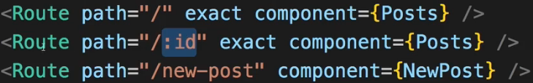  
=> This will be replaced dynamically. Or essentially it tells React Router - hey, whenever you have /:something, this route here is meant.  
  
so just :id. And yes, this will interfere with this route:  
  
=> We’ll take care about this by simply changing the position  
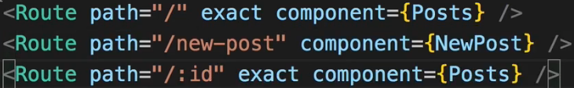  
because it’s parsed from top to bottom so /new-post is recognized first and :id doesn’t accidentally catch the new-post.  
* Now of course we also want to make sure that we pass the parameter when clicking on a route now.  
=> For that we need to handle a click on a single Post in the Posts.js component.  
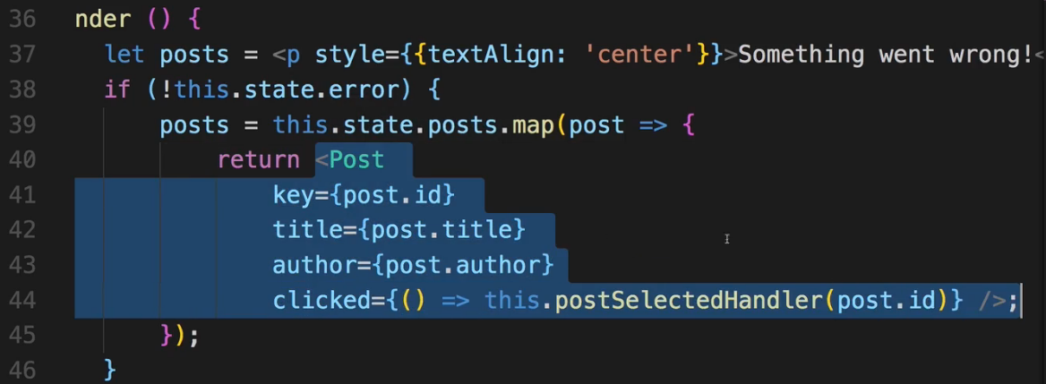  
=> And there would be 2 ways of doing that.  
=> 1. => The first is to simply wrap that Post component with a Link. And that would be perfectly fine and maybe the default way you do it.  
* Setting `to` to something dynamic - and that dynamic should be our ID. Potentially of course if you have longer URLs where you have something like /posts/ and then the ID, you might also mix a string and then your ID or whatever it is.  
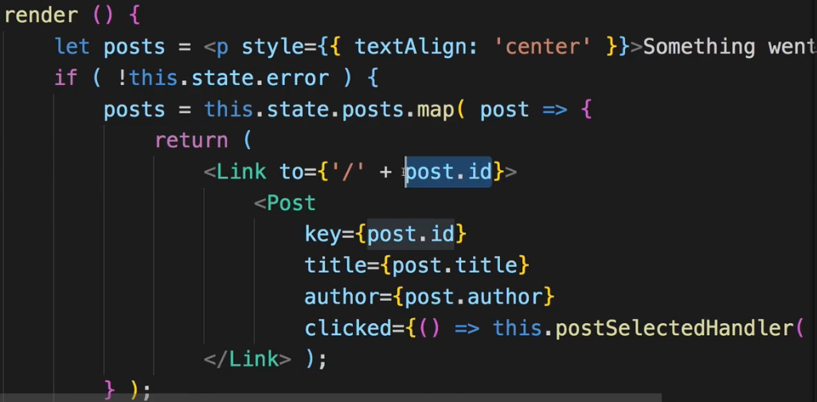 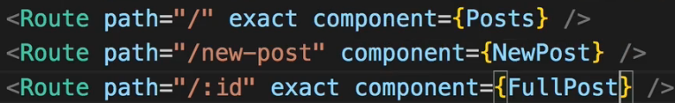  
=> We get a missing `key` error => because Link is now the outer element in our array of elements.  
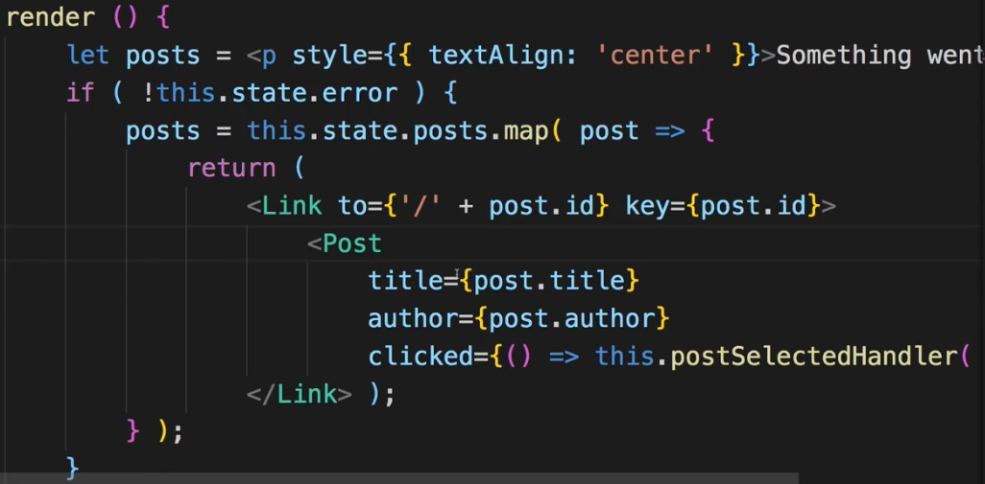  
=> Now if you click on a post, you can see there is the ID in the URL:  
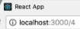   
=> We don’t load the post successfully because `this.props.id` in the FullPost component is not set anymore, it’s not how we retrieve the parameter we’re passing through the route url.  
**Extracting Route Parameters**  
* In FullPost.js:  
* Turn **componentDidUpdate()** to **componentDidMount()** because now we’re not updating this, it’s getting added or removed to and from the DOM so this needs to be componentDidMount().  
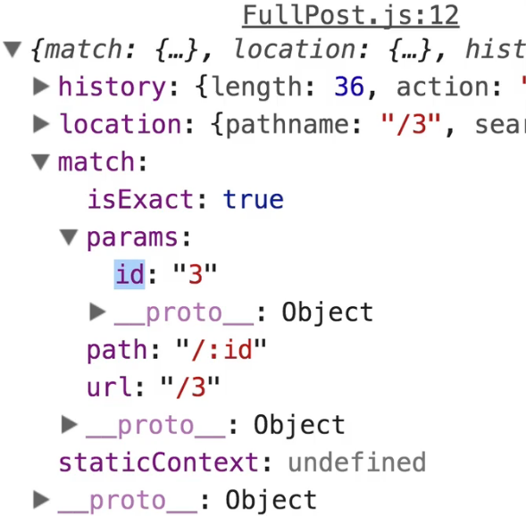 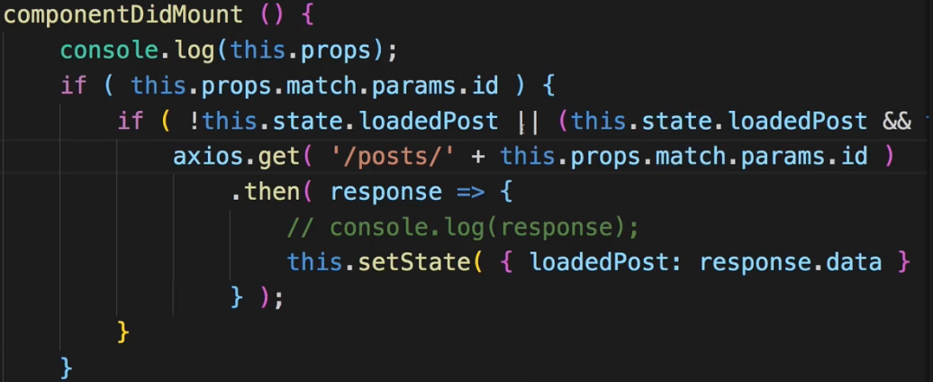  
=> Now it works and shows the post with the appropriate ID.  
* So now we really have an application where we have a dynamic element because we are successfully passing route parameters and extracting them.  
* Now there are still a couple of things which don’t exactly work the way we want to:  
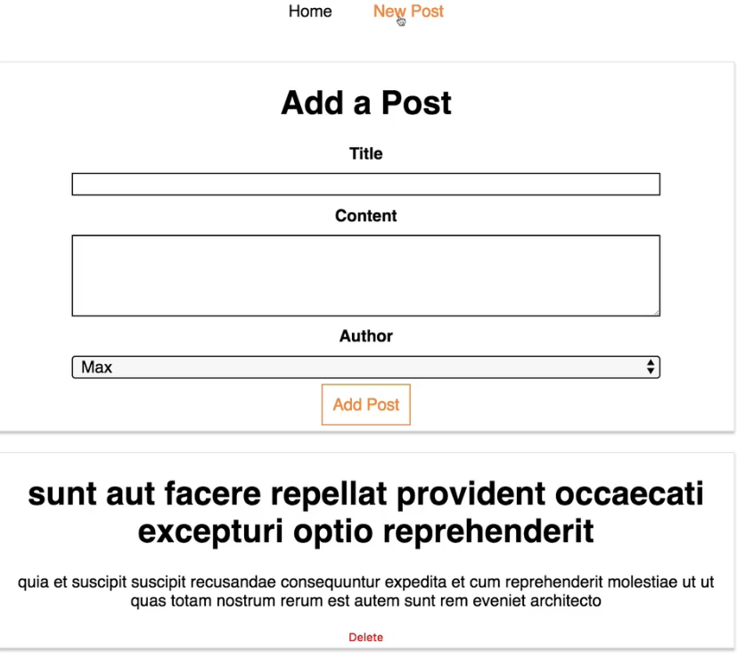  
=> For example on the New Post we are loading the new post form but we also load that single post.  
**Parsing Query Parameters & the Fragment**  
You learned how to extract route parameters (=> :id  etc).   
But how do you extract **search** (also referred to as "**query**") **parameters**(=> ?something=somevalue  at the end of the URL)? How do you extract the **fragment** (=> #something  at the end of the URL)?

#### **Query Params:** You can pass them easily like this: <Link to="/my-path?start=5">Go to Start</Link>  or

1. <Link
2. to={‌{
3. pathname: '/my-path',
4. search: '?start=5'
5. }}
6. >Go to Start</Link>

React router makes it easy to get access to the search string: props.location.search .  
But that will only give you something like ?start=5   
You probably want to get the key-value pair, without the ?  and the = . Here's a snippet which allows you to easily extract that information:

1. componentDidMount() {
2. const query = new URLSearchParams(this.props.location.search);
3. for (let param of query.entries()) {
4. console.log(param); // yields ['start', '5']
5. }
6. }

URLSearchParams  is a built-in object, shipping with vanilla JavaScript. It returns an object, which exposes the entries()  method. entries()  returns an Iterator - basically a construct which can be used in a for...of...  loop (as shown above).  
When looping through query.entries() , you get **arrays** where the first element is the **key name** (e.g. start ) and the second element is the assigned **value** (e.g. 5 ).  
**Fragment:**  
You can pass it easily like this:  
<Link to="/my-path#start-position">Go to Start</Link>   
or

1. <Link
2. to={‌{
3. pathname: '/my-path',
4. hash: 'start-position'
5. }}
6. >Go to Start</Link>  
   React router makes it easy to extract the fragment. You can simply access props.location.hash .

**Using Switch to Load a Single Route**  
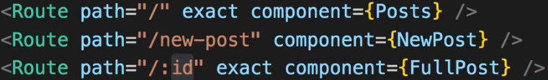  
* All Route-s here are rendered if they match the path.  
* Now of course we could fix it by using /posts/:id and also fixing it in Posts.js to /posts/ + post.id.  
* But sometimes you simply have to use a given URL because your URLs would otherwise look not the way you want them to look in the end.  
=> We can still tell React Router to load only 1 of all these Route-s at a time.  
  
=> The **Switch** component.  
=> **Loads the first Route that matches**. So the **order is important** here.  
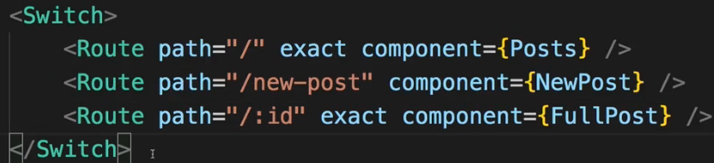

* And of course you can mix it, you can have Route-s outside Switch.  
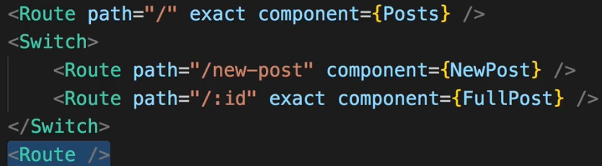  
**Navigating Programmatically**  
* In Posts.js:  
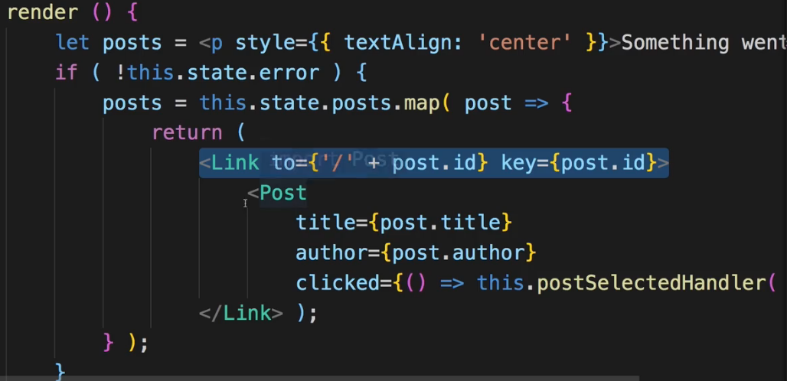  
we’re now using a Link to load a single Post and navigate to its page and there’s nothing wrong with that.  
* However, I now want to show you an alternative.  
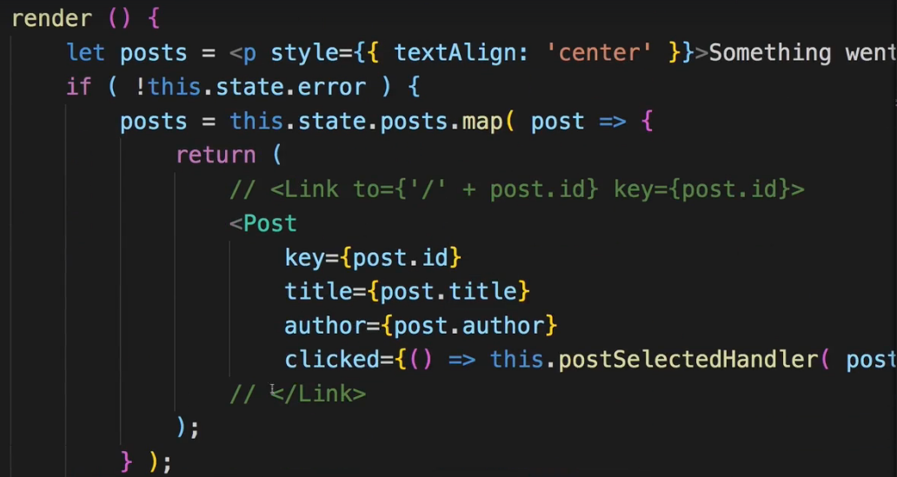  
* Right now I have to find some other way of going to that Post.   
* And remember that we have this clicked listener where we execute this postSelectedHandler(post.id) where we also pass the ID.   
=> We can use that method.  
=> And here I don’t want to use the STATE, instead, I want to navigate programmatically.  
* I’m showing you this is a demo - of course using the Link would be fine for this use case.  
* But you also sometimes have use cases where you want to navigate after something finished.  
=> After HTTP Request was sent for example.  
=> To do this, we can take advantage of that `history` object we receive on props. And there we actually have some functions we can execute. Functions for navigating around, like goBack or goForward which basically do the same we have with the forward/backward buttons in browser.  
=> There also is this `.**push()**` method which allows you to push a new page onto the stack of pages. Because navigation basically just is about a stack of pages. That is why the back and forward buttons work in the browser - because you can go back to the last page on the stack of pages or forward again to that page on the stack you had on the top of it before you went back.  
=> We can use a string or an object in it so essentially the same we use in router link on to `to` property to navigate to a page.  
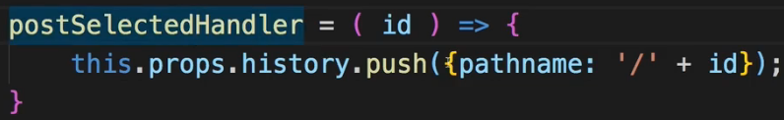  
* You could also just use:  
  
* Now if I go back to my application to Home and I click on a post, that still works. Now, however, **navigating programmatically**.  
=> **This can be important from time to time mostly used AFTER a given operation finished**.  
**Additional Information Regarding Active Links**  
* We have that Home link which is not marked as active when being on a single post. And it kind of makes sense by the label of it. But what if this was named Posts which would make sense because we have a lot of posts there so let’s rename that link to be “posts”. Now it will be strange it’s not highlighted when we are on a single post. We certainly would want this.  
=> Now the reason for this of course is `exact` - since `exact` is set, this only is treated as active if we have exactly this “/” URL and not “/3”.  
=> The problem is if we remove `exact`, now it will be marked as active for a single post but also for a new post. So this is kind of tricky and it’s just for this exact case that we’re talking about the root URL.  
=> I’m going to add `exact` again, you would normally have /posts/3 anyway.  
* I just wanted to bring this to your awareness - you can face issues when using the root path - just “/” and you want to style some child components but not all of them, this is really tricky to do.  
**Understanding Nested Routes**  
* Thus far in our application we loaded the single post route as part of our blog page so that when we click on a post, we exchange the posts page for the single post page.   
* Now we can absolutely do that of course.  
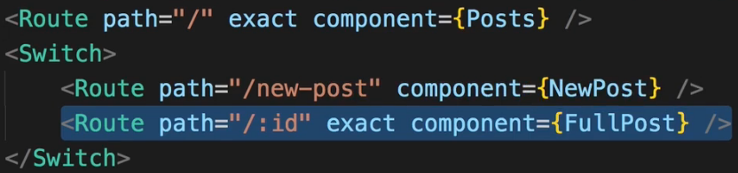  
* However, sometimes you also have a setup where you want to create a nested route.  
* So where you want to load a certain component or you want to render a certain content inside of another component, which is also loaded via routing.  
* So right now we have only 1 level where we do routing.  
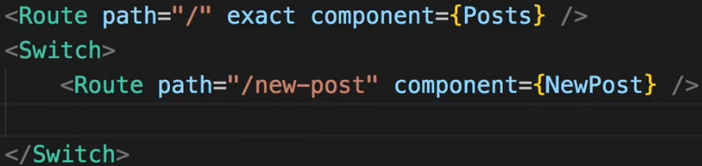  
* In Posts.js:  
* Now let’s say we want to load a specific post not inside the Blog.js component but inside the Posts.js right beneath our posts here.  
=> So for that I will wrap this in a DIV and add my Route component in there.  
  
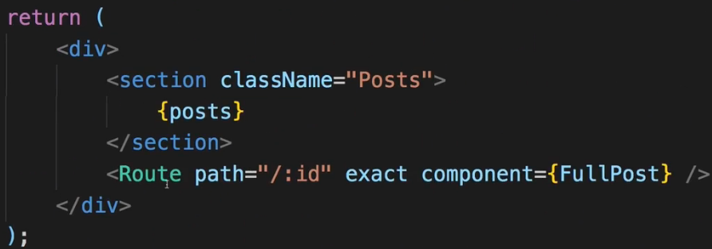  
=> And now I can render a single post beneath my list of posts because I use Route in a different component. You can use React Router features anywhere inside BrowserRouter component.  
* Now if you go to your Posts and you click on a single post, the URL updates but the post isn’t rendered and the posts are gone too.  
=> The reason for this is that we now create a nested route.  
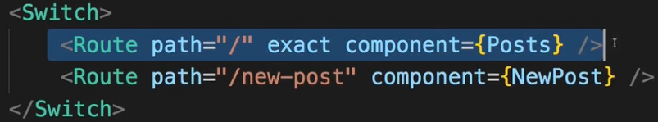  
=> We have the root route let’s say, here in the Blog.js container, this is the top-most level where we react to any route changes and then in the Posts.js component which we load through the Router - keep that in mind - we loaded, we implemented through the Router - in this Posts.js component here, we now again use Route.  
=> The issue is for “/:id” we’re not going to reach that route because we have an `exact` matching for just “/”. So “/:id” doesn’t match that route so the Posts component never gets rendered which is too bad because it would be in that component that we want to render our FullPost component for a given ID.  
=> Now to fix this, we can of course remove `exact`. Then this will match “/” and “/3” and so on.  
=> We should then change the order though so that the “/” doesn’t also consume the “/new-post”.  
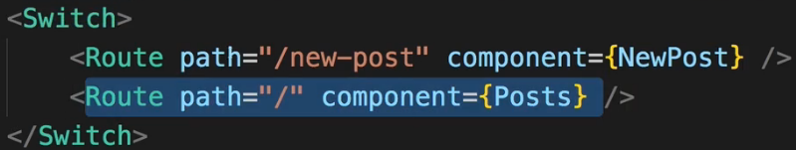  
* And now Switch makes sense again because now the “/” would also be rendered for “/new-post”.  
* So now indeed we can load a single route beneath our routes. So if I go to just “/”, we see just the posts but if I click on a post, we load that beneath the posts.  
* This already is a nested route.  
* We face an issue though - let’s say we have “/posts” here:  
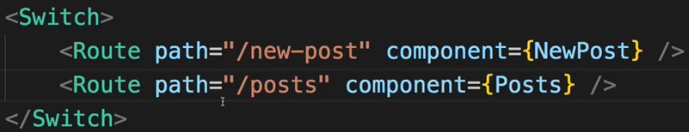  
=> And of course this means that in the Posts.js component, where we navigate if we were to use a link, we would have to update this to “/posts/” everywhere.  
=> Now with this in place, if I click on Posts here, we load the posts, and I can click on a post of course. Now you see also that it fails though - we get an error because our nested route here in the Posts.js component:  
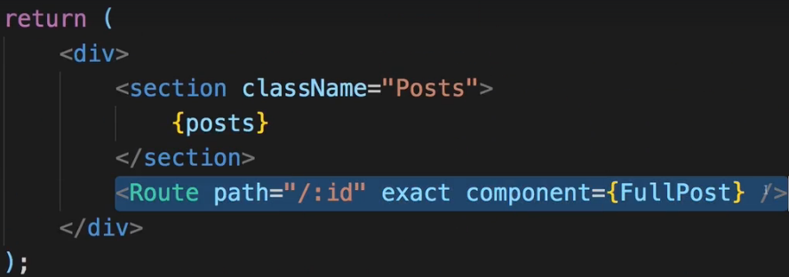  
parses “/:id” and this is not appended to the path of the route which was responsible for loading the posts component. So this is not automatically resolved to “/posts/:id”, this is not happening. Instead this still is slash root slash ID “/:id” so we would have to update this to “/posts/:id” too to have working nested routing again with our new URL which is “/posts/:id”.  
=> It’s of course very cumbersome to do so - so instead of using “/posts” like this, a better way is to get the current path dynamically. So that this really is a dynamic, a flexible, nested route.  
=> And for that `path` should be set to something dynamic here not a hard-coded string.  
=> And in there we probably should use `**this.props.match.url**` which is basically the URL we loaded thus far. So the URL which was responsible for loading this Posts.js component and that of course is exactly the part we need to pre-pend to our flexible part thereafter.  
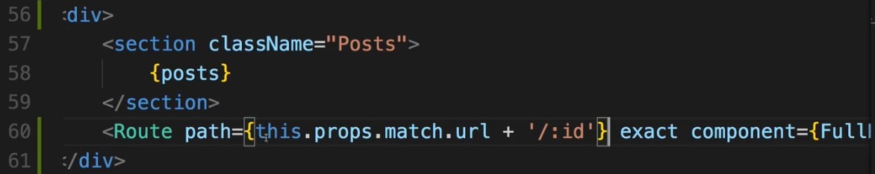  
=> Now this will match /posts/:id and if we ever were to load this component differently - let’s say on /all-posts, then this would automatically resolve to /all-posts/:id here because it is dynamic.  
* This is how you create truly nested routes in your React application with React Router.  
**Creating Dynamic Nested Routes**  
* Now you might have noticed 1 thing maybe even earlier - when we are on a given post, and we click on a different post, we don’t actually load that - though you can see in the URL that the ID changes.  
=> So it is registering the click but it isn’t loading the new component.  
=> The reason for this is that React Router behind the scenes doesn’t replace the component all the time. If you are loading a component on which you’re already on, like we are here - it won’t re-render the whole component and therefore for the FullPost, **componentDidMount()** isn’t executed again because the component itself didn’t change, it would be very inefficient to unmount it and remount it.  
=> So since componentDidMount() isn’t executed though, we’re not reaching out to the web again.  
=> So to fix this, we should also implement **componentDidUpdate()** to handle this case because this one will be executed again.  
=> Let’s move the code for reaching out to the web into a method because now I want to call this both in componentDidMount() and componentDidUpdate().  
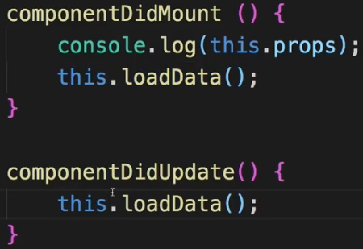  
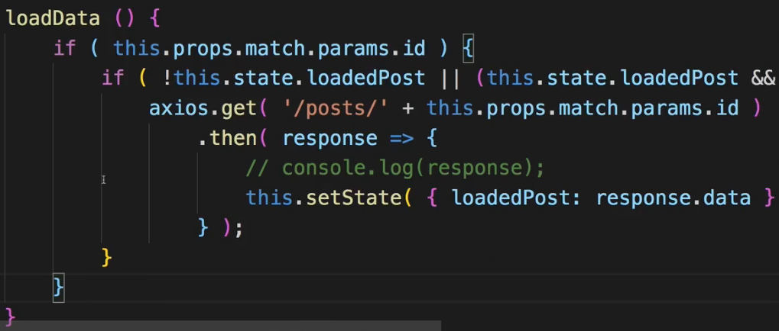  
=> Now, however, you see by the console.log() already that we have an **infinite** **loop**.  
=> So this is not the perfect solution, I click on a link here and it keeps loading. So definitely not what we want to do. What wrong with our current setup here?  
=> Well it’s our check in loadData method.  
  
=> We’re checking if our ID changed and we’re checking for `this.props.id`.   
=> Now just as everywhere else here this needs to be `**this.props.match.params.id**`.  
  
=> So we have the same infinite loop problem we had in the HTTP section because our check here wasn’t working anymore.  
=> **And we need to update this everywhere in our component where we reference `this.props.id`**.  
* **Now with all these changes in place, it would still not work because the ID we’re retrieving from the route params is actually going to be a string**.   
=> **Now here we’re checking for type equality too**:  
  
**and the ID stored in the loadedPost actually is a number**.  
=> So we either have to convert the string ID into a number or simply turn this into a check where we just check for the value.  
  
=> Now if we check just for the value and we click a post, now you see it’s not loading all the time, instead it only loads once but it correctly updates it when we switch the post.  
=> Again the alternative would be to leave the type equality !== check but **convert** the `this.props.match.params.id` **to a number by adding a +** for example.  
  
* This is an important fix to the FullPost component in general, that we use `this.props.match.params.id` all over in the component and it’s also important to understand that you need to handle changes in componentDidUpdate() if the component in general is already loaded through routing because the Router will not unmount the old one and mount the same one again with different data, it will reuse the old one and just adjust the route parameter, it’s your job to react to this new parameter and you can react to that in **componentDidUpdate() which will be called because the PROPS changed**, **you receive a new PROPS with a new `match` object with a new `params` object with the new ID**.  
* This is important to understand when working with nested routes.  
**Redirecting Requests**  
* Let’s you want to redirect the user to the /posts if he visits just /.  
* You can have multiple paths which render the same content, that’s absolutely fine.  
=> **Redirect** component is simply used in your JSX code like a normal component.  
=> It has a `**from**` and `**to**` property.  
  
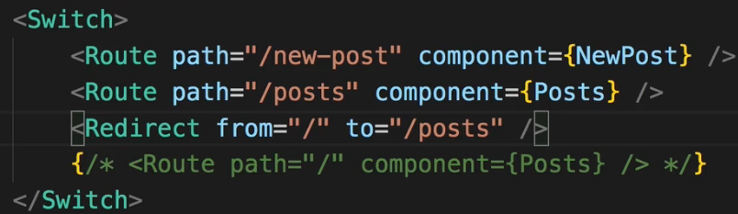  
=> **If you use it outside of the Switch statement, `from` can’t be specified. Then you can just always redirect `to` /posts and not respect the path you were navigating to**.  
=> Now it’s just like another Route - the only difference is it doesn’t render content, it simply just changes the URL so that we then reach another Route for which we render content.  
**Conditional Redirects**  
* In NewPost.js we probably want to redirect once we click the submit button here and once we made our HTTP Request.  
* We often then want to change the page and not remain on that page.  
  
* **Now if we place a Redirect here outside of a Switch statement, we always have to redirect with the `to` property though, we can’t use `from`**.  
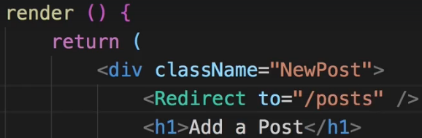  
=> We need to render this conditionally, otherwise we’re redirected immediatelly.  
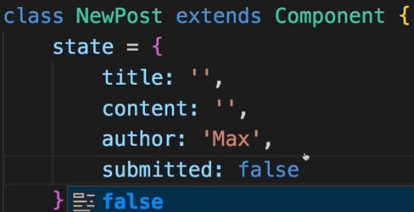

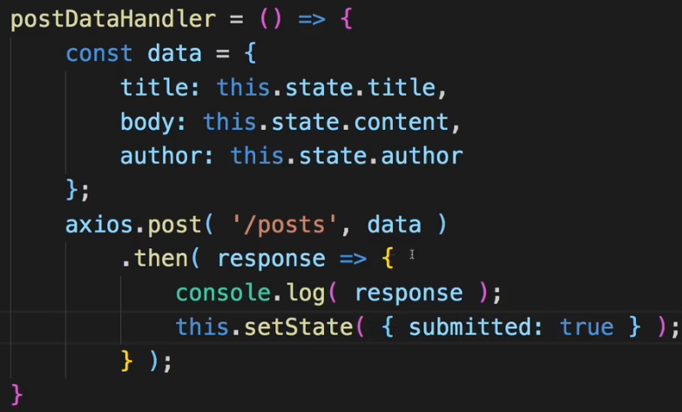 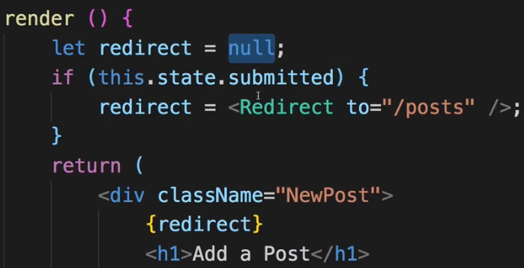  
**Using the History Prop to Redirect (Replace)**  
* Now to be honest the previous way of redirecting is maybe not the way you’re always going to do that. In the end after submitting a post successfully, you just want to switch the page. And for that you can of course also use that `**history**` prop which you get on every component which is loaded inside BrowserRouter.  
=> And that `history` prop has a couple of convenience methods we can use for replacing the current route or pushing a new route.  
=> So we can change the page here without changing the state but instead by accessing `**this.props.history.push()**` method which allows us to push a new page.  
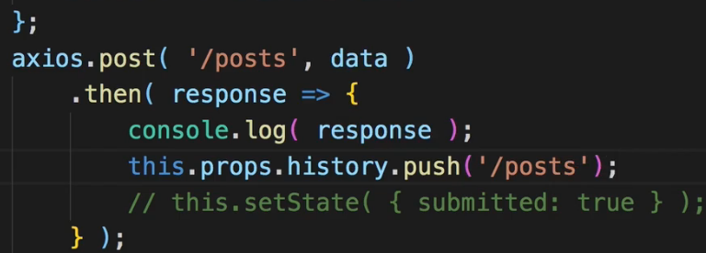=> This will essentially lead to he same behavior as before.  
=> Technically `push` pushes this page onto the stack so if you click the BACK button in browser, we got back to the NewPost page whereas Redirect replaces the current page so if you click the BACK button after Redirect, you can go back but you won’t go back to the last page because Redirect replaces the current page on the stack, it doesn’t push a new one.  
=> Redirect could be replicated by using `**this.props.history.replace()**`.  
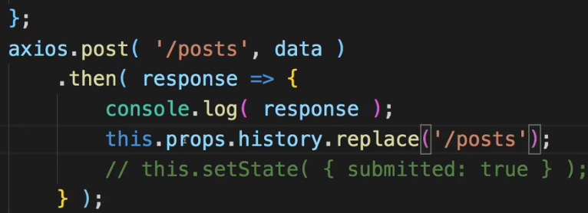  
* I wanted to show you both ways though because maybe you have a use case where you want to render that Redirect component conditionally and then this is an easy way of doing it.  
**Working with Guards**  
* This is something which is kind of related to redirecting.  
* **Navigation Guards**.  
* A Guard is something you might know from other Frameworks and their routers.  
=> A typical Guard is for example used when you don’t know whether the user is Authenticated or not and there are some parts in your application, some routes you only want to allow the user to visit if he is Authenticated.  
=> With the React Router you might need to have to think about these Guards in a new way.  
* For example in the Blog.js container here where we set up the routing for NewPost and so on --- since in the end all we’re doing here is just rendering some components: the Route component, the Switch component, if we want to make sure that NewPost can’t be reached, we can simply render this conditionally.   
* Let’s add a state for that. And we can use a ternary statement.  
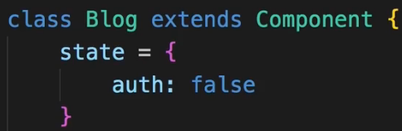 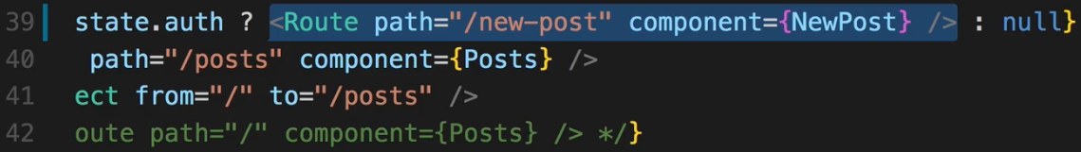  
=> Now if I click on the New Post, I’m redirected to the /posts starting page because what’s basically happening here is: Redirect kicks in her as I said `from` here is basically just used as a prefix and therefore it catches everything which isn’t caught before and redirects it to /posts.  
=> This is a Guard, it’s totally different then we use Guards in Angular or any other Framework but in the end this is how you can conveniently control whether the user is allowed to access this page or not.  
=> Of course an alternative to this would be to go to that Guarded Page and inside **componentDidMount()** you could also check if the user is Authenticated and of course it depends on the application from where you’re getting that information. You could simply use `this.props.history.replace()` if user is not authenticated.  
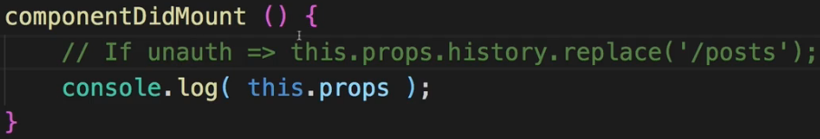  
* This is how you work with React Router, this is how I want you to think about it, you control a lot of it by the way you render its components and if that route isn’t rendered, you can’t reach that route, the definition isn’t rendered so the component connected to it, can’t be loaded. This is how you have to think about it and how you have to structure your application. Wrap your head around this, this is really crucial to get right and crucial to understand.  
**Handling the 404 Case (Unknown Routes)**  
* We actually saw 1 way of handling it with Redirect here:  
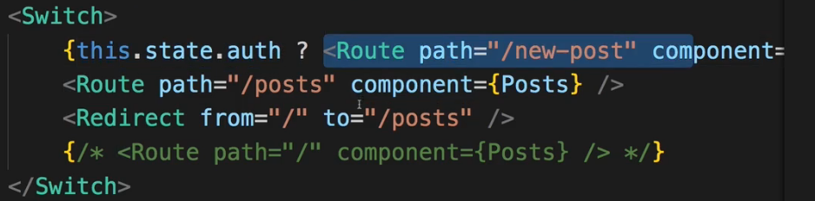  
* Because if we try to access NewPost when not authenticated, this route is unknown because it’s not rendered and as you could see, if we still click on New Post, we are essentially redirected back to /posts. This is one way of handling 404 Requests, you can simply redirect to another route.  
* However, you can also handle them in a different way.  
=> **You can specify the Route component here and if you leave out the `path` so you don’t add path, you can simply define a `component` or the `render` method to render something for any unknown route**.   
* Now it won’t work together with Redirect from the the “/” root route because this also catches all and the one that’s wrote first wins. For any other use cases where you don’t Redirect from the root “/” route though, you can use them together.   
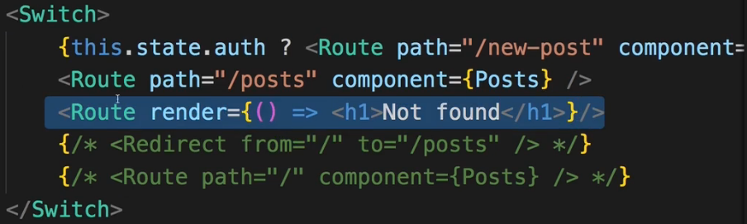  
* But here this is a nice Catch All Route which should always come last and show an appropriate page or render some dummy content for unknown routes.  
**Loading Routes Lazily**  
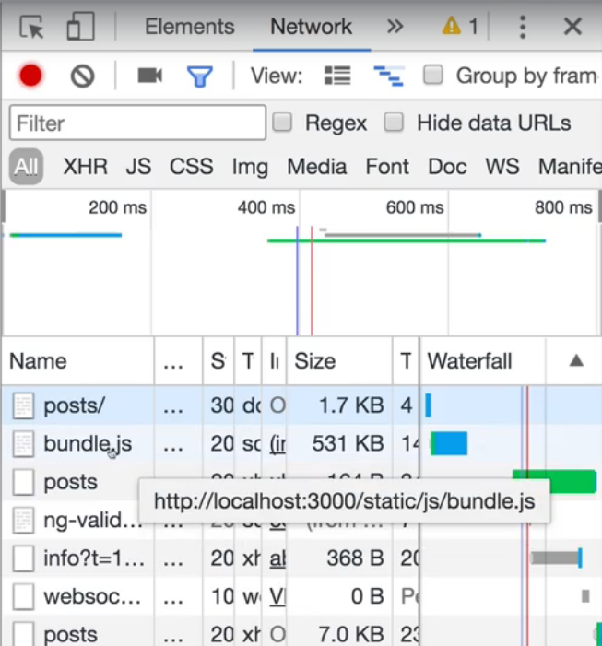  
=> If we go to the Network tab, we can see that we’re loading this bundle.js file.  
=> This contains all our source code and here is relatively big because we’re in development mode, it will be much smaller once you’re shipping this for production, it’s optimized by our build workflow automatically.  
=> This loading the entire bundle.js with all the code of our application upfront can be bad if we have a big application with distinct features and distinct areas in the app where a user might never visit a certain area.  
=> Our NewPost for example - this should only be loaded if a user visits it.  
* Now for a tiny application like we have this isn’t super useful because making that extra Request for 1kb or smomething that this component is worth, that’s not super useful.  
* But it is useful to know this technique for a bigger application where this might matter, where you are downloading quite a bit.  
=> The technique of only downloading what you need is known as **Code** **Splitting** / **Lazy** **Loading**.  
=> To implement this with create-react-app and React Router 4 - and that’s important, this technique will work for React Router 4 and for create-react-app because Code Splitting depends heavily on the **webpack** configuration you’re using. It is an advanced concept after all.  
* So this way will work with the config from create-react-app which is a pretty modern and good configuration though so chances are it also works in any other decently set up webpack project or as I said earlier I strongly recommend using create-react-app anyways.  
=> For this we need a **HOC - Higher Order Component**.  
=> Creating a `hoc` folder and `asyncComponent.js` in it.  
=> **This component or this code here should help me load a component asynchronously = only when it’s needed**.  
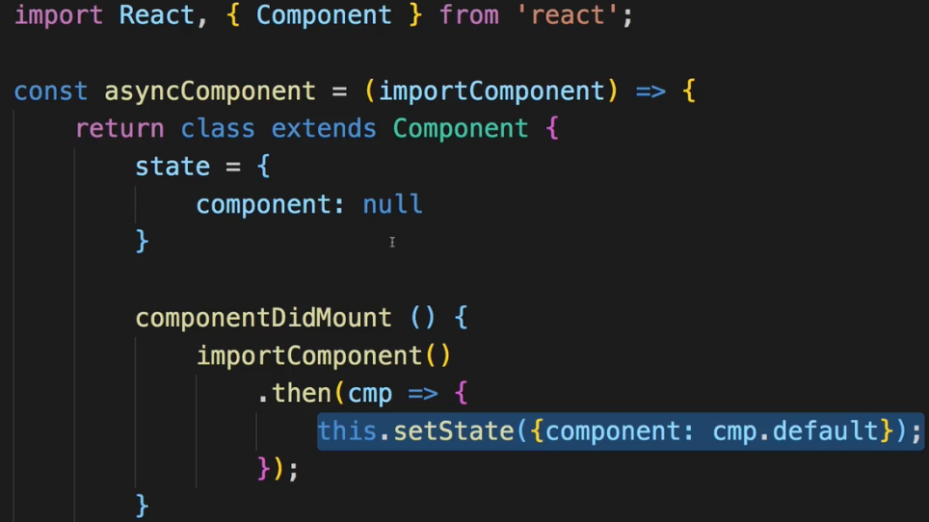  
* This state here this `component` will be set to the dynamically loaded component and the code for this will be implemented in **componentDidMount()** so once this wrapping HOC has been mounted.  
* Now `importComponent` should be a function reference in the end.  
=> This will be a function which will return us a **PROMISE**.  
=> In the function of this .then() block we’ll get an argument `cmd` for example, which will have a 1 property - default - which will be the component we loaded dynamically.  
* Now at some point of time we will have loaded the actual component we want to use and it will be stored in our state.  
=> Hence in the render() method we want to render it.  
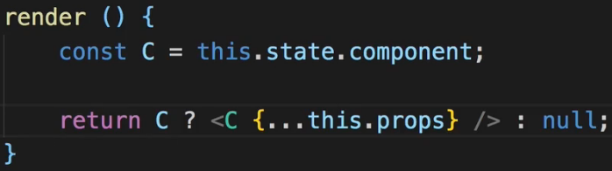  
* Now back in Blog.js:  
=> I want to load this NewPost.js here dynamically now.  
* Now the thing is whenever you’re importing something like this with “import something from somewhere”, you basically inform webpack - the build tool which gets used behind the scenes - about this dependency and it will include it in the global bundle.js, this is its job.  
=> Now for Lazy Loading this is exactly the opposite of what we wanna do. We don’t want to include it in the bundle.js, we want to load it when needed. Still webpack needs to be able to dynamically prepare some extra bundle for this potentially loaded code.  
=> **import()** keyword as a function - this is a special syntax, the **dynamic import syntax**, which means: whatever comes between the parenthesis () here is only imported when that function here is executed.  
=> **And that function here will only be executed once we render AsyncNewPost to the screen**.  
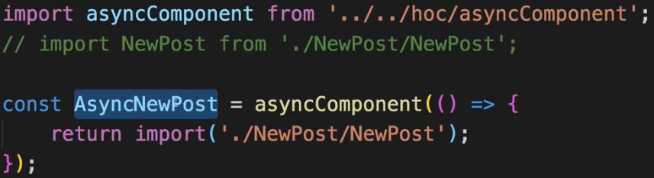  
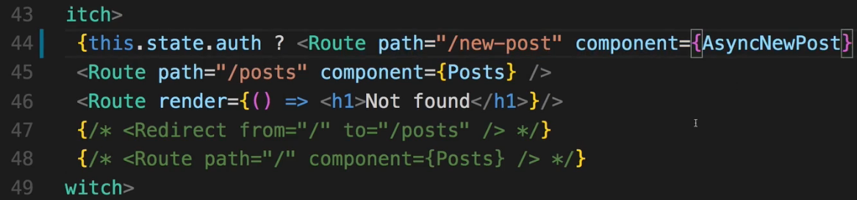  
=> I want to use AsyncNewPost as a component instead of NewPost, eventually this will be a component because keep in mind - **asyncComponent** returns a component, it will eventually render some dynamically loaded component and we decide which component this should be with the function we passed to asyncComponent.  
  


=> Now if we save this and we go back to our application, this is at the home Posts:  
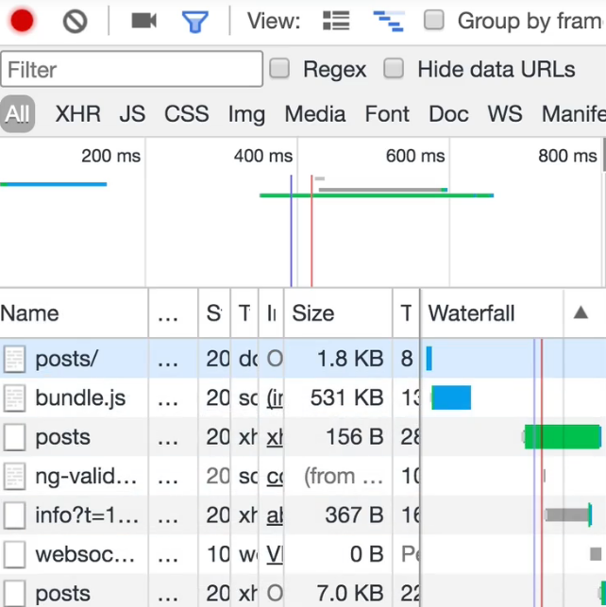 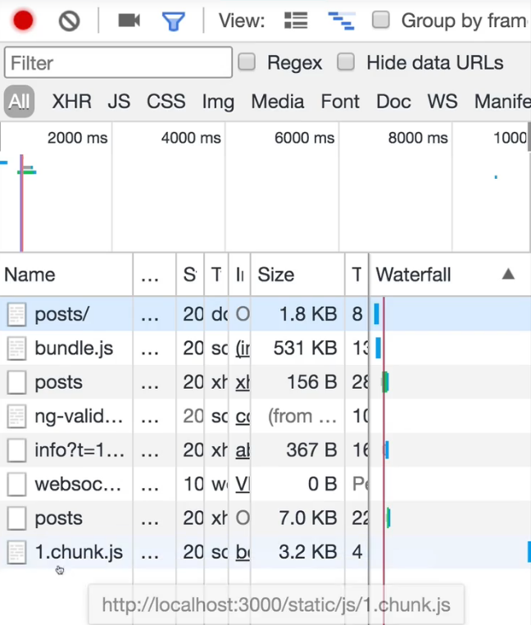  
=> Once I click the New Post, you see that this 1.chunk.js file was loaded, which is very small.  
=> This is an extra bundle webpack created because while bundling our code, it detected this dynamic syntax here import() which it knows due to our setup we’re using - due to this build workflow setup, and therefore it created an extra bundle with the NewPost component and all potential child components that were exclusive to that component, if any. But it didn’t add it to the main bundle.js, instead it’s prepared to load it when needed when we actually include asyncNewPost, which we only do when navigating to “/new-post”.  
* This is how you load components asynchronously.  
* And as I mentioned this is extremely useful in bigger apps where there are bigger chunks of code, a whole feature area in your application for example which might not even be visitted by the user so you can save that code upfront to only load it when needed  
**Routing and Server Deployment**  
* Now there is 1 important thing you have to know regarding routing when using the React Router when it comes to deploying your app to a real server because you won’t notice it here on the development server because it’s already configured correctly.  
=> You have to remember how handling Requests actually works in the Web.  
* We have the user who sends a Request to the server and we have our React app which is then loaded on the index.html page.  
* The thing is - before we load the index.html page, the server needs to find out which page the user actually wanted to visit. That of course is the case because the server always handles Requests first. This is how the internet works.  
* The problem is, it’s the React app which knows the routes.  
* So if we visit “/posts”, there is no “/posts” route on our server. That is defined in the JavaScript code which is loaded on the index.html page which we never get because we get a 404 Error on the server, because we tried to visit a route which is unknown to the server. This is not what you saw in the development server because the development server is already configured correctly.  
=> We have to configure the server in a way that it always forwards Requests no matter if it understands them or not, so also 404 error Requests to the client. So that it always returns the index.html page, also for unknown Requests, because this then allows React to take over and parse the Request against the routes it knows, so we should always load index.html and if then there is a Request we don’t know, our app handles that for example as we handled 404 errors.   
* Now as I said the development server we used here already is configured to always load the index.html file.  
* It is something you also have to do when hosting the app on your own server though. Always return index.html, even and especially in 404 error cases.  
* There is 1 other thing you have to be aware of when hosting your app on your server:  
=> If you’re hosting it on let’s say “example.com” so if that is the page with which we’re landing on the root page of your React app, you don’t need to set up anything special.  
=> But if you’re serving your app from let’s say “example.com/my-app” so anything beneath that folder should be your React app, you need to tell React Router about this.  
=> You need to set the `**base path**` for the React Router.  
=> In your application, in the place where you use **BrowserRouter**, so in our case in the App.js file, you can also configure that and you rarely need to do that, but there is a `**basename**` prop you can set and by default that’s set to “/”.  
=> If you’re serving your app from “/my-app”, you should set this to “/my-app”.  
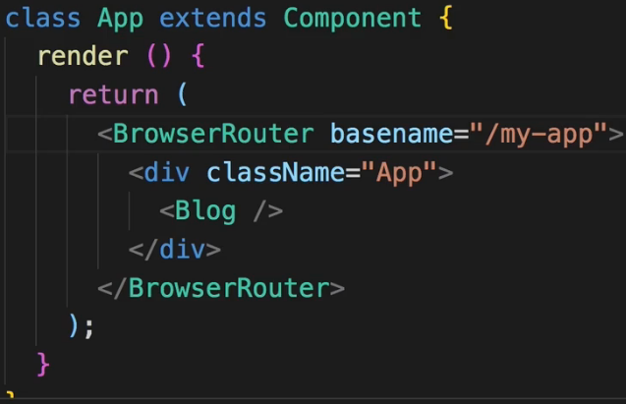  
=> Then all your Requests are routed against “/my-app/” and then the link you were pointing to. Otherwise, if you had a link like here in Posts.js   
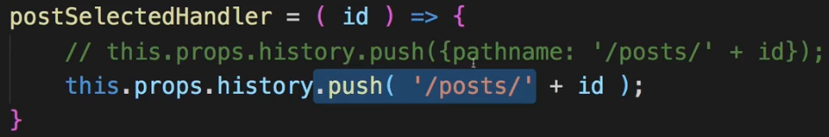  
- if you push the page change upon clicking a post, here we navigate to “/posts/” and it would always add this to your root domain. Now if your React app is served from “/my-app”, it will only work correctly and add it to the end of yourdomain/my-app if `basename` is set up.  
* So whenever you’re serving your app from a sub-directory, make sure to set `basename`.  
**Assignment: Time to Practice - Routing**  
**Wrap Up**  
* You now have a way of turning your Single Page Application (SPA) into a felt-like Multi-Page Application and really leveraging the power of React, presenting the user with a great user experience which looks and feels like a normal web page by having all the reactivity of a JavaScript-only driven web app.  
**React Router Docs**: <https://reacttraining.com/react-router/web/guides/philosophy>